



Invitation to the Inaugural Lecture of
Prof. Dr. First Name Last Name
Full Professor
of the Faculty of Business, Economics and Informatics

Monday, 17 February 202x, 5 pm
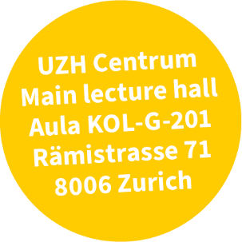
Title of the Inaugural Lecture

After the lecture you are cordially invited to the apéro in the Lichthof.

